**DAILY ONLINE ACTIVITIES SUMMARY**

|  |  |  |  |  |  |  |  |  |
| --- | --- | --- | --- | --- | --- | --- | --- | --- |
| **Date:** | **23/05/2020** | | | | | **Name:** | **POOJA D S** | |
| **Sem & Sec** | **4th SEM 'B' Section** | | | | | **USN:** | **4AL18CS056** | |
| **Online Test Summary** | | | | | | | | |
| **Subject** | | **Data Communication** | | | | | | |
| **Max. Marks** | | **30** | | **Score** | | | **25** | |
| **Certification Course Summary** | | | | | | | | |
| **Course** | **Java programming** | | | | | | | |
| **Certificate Provider** | | | **Great Learning Academy** | | **Duration** | | | **3.5 hour** |
| **Coding Challenges** | | | | | | | | |
| **Problem Statement:** A user will input two strings, and we find if one of the strings is a sub sequence of the other. Program prints “yes” if either the first string is a sub sequence of the second string or the second string is a sub sequence of the first string. Assume that, the length of the first string is smaller than or equal to the length of the second string. Assume that, the length of the first string is smaller than or equal to the length of the second string. | | | | | | | | |
| **Status: completed** | | | | | | | | |
| **Uploaded the report in Github** | | | | | **yes** | | | |
| **If yes Repository name** | | | | | <https://github.com/dspooja/C-coding> | | | |
| **Uploaded the report in slack** | | | | | **yes** | | | |

Online Test Details: (Attach the snapshot and briefly write the report for the same)

Certification Course Details: (Attach the snapshot and briefly write the report for the same)

Coding Challenges Details: (Attach the snapshot and briefly write the report for the same)

ONLINE TEST DETAILS:

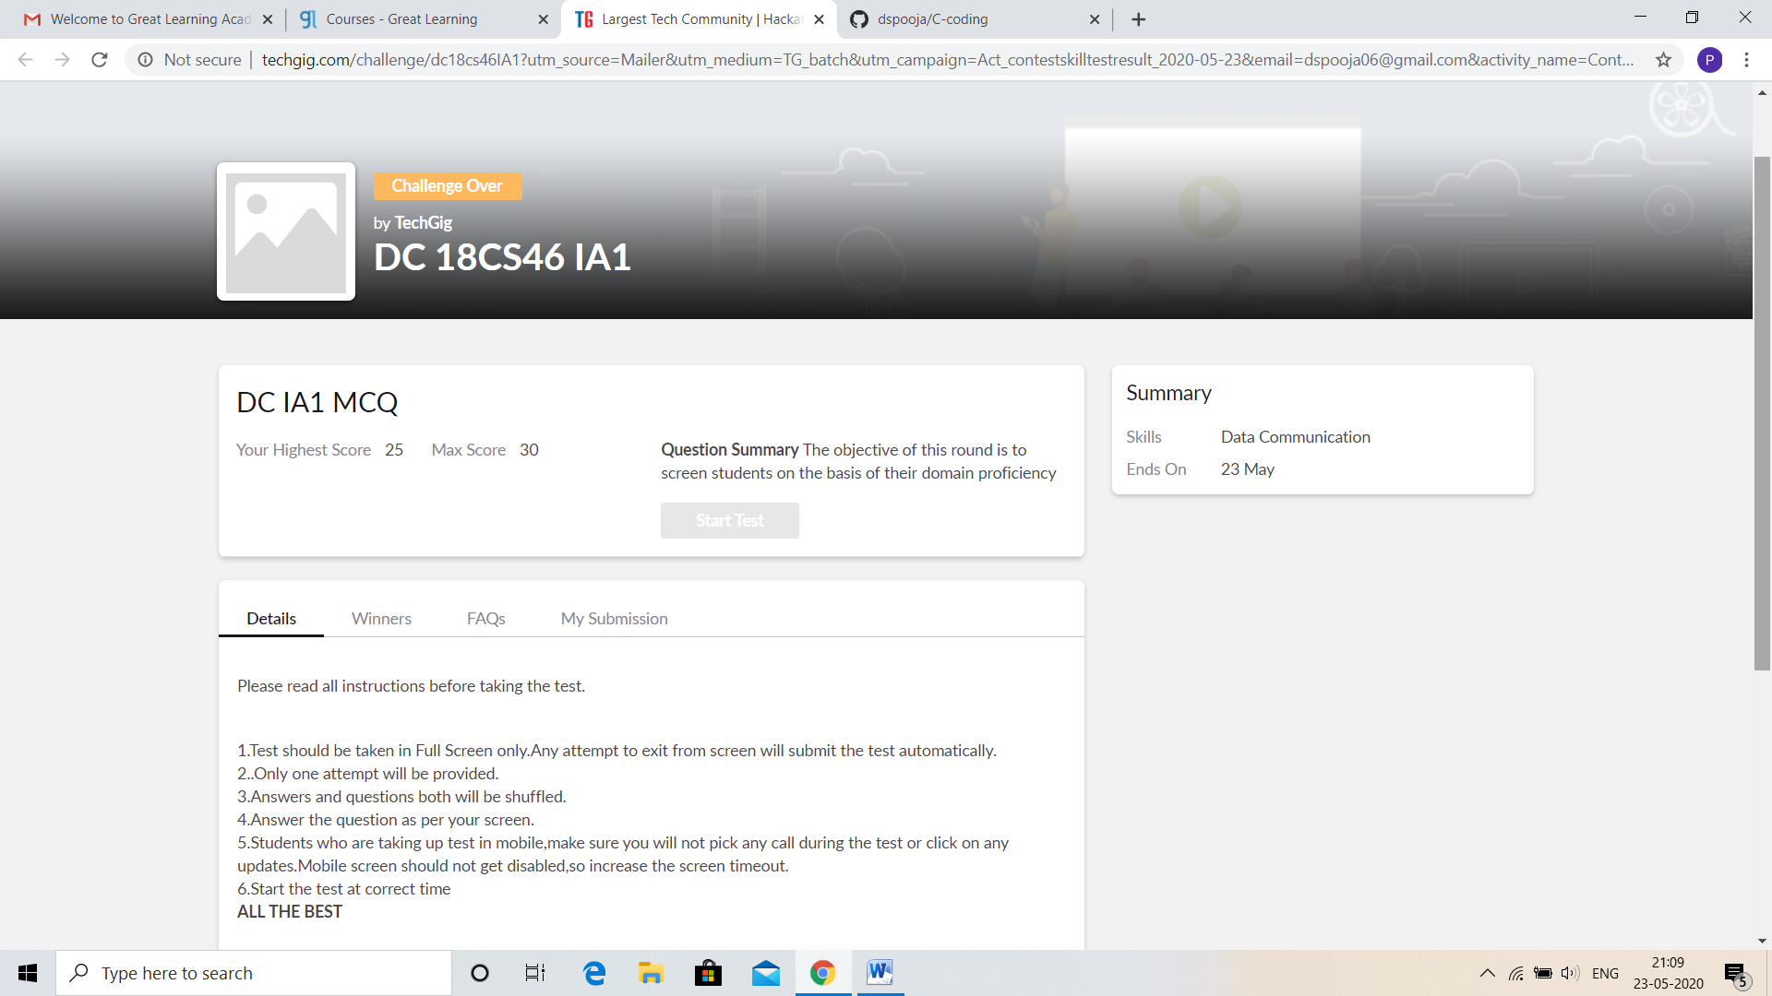

CERTIFICATION COURSE DETAILS:

* As continuation of the online course Java Programming.
* **The concepts covered are:**
* Variables and Data Types
* Operators in Java
* Flow Control Statements in Java
* Arrays in Java
* Functions in Java

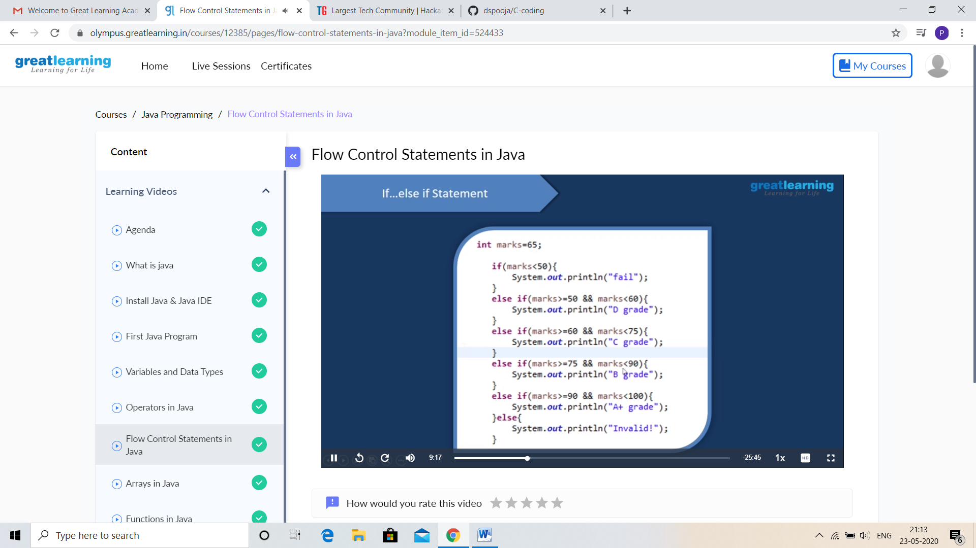

CODING CHALLENGES DETAILS:

Problem statement 1:

Write a C Program to generate first N Triangular Numbers (Where N is Read from the Key board).

Solution : Uploaded it in github

